REGIONAL WAREHOUSE LOGISTICS COORDINATOR ( REVERSAL PICK PACK TO

Reversal SO DO done by parts coordinator , then the receipt is assigned to the regional warehouse logistics coordinator for the reversal pick pack update .

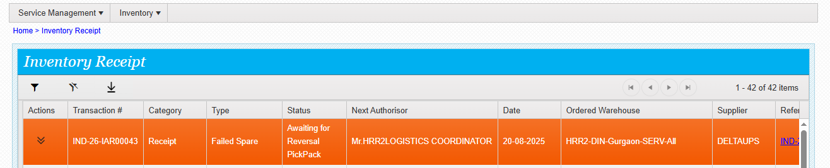

Regional warehouse logistics coordinator type the URL

https://mcis.deltaiserve.net/

DO THE LOGIN

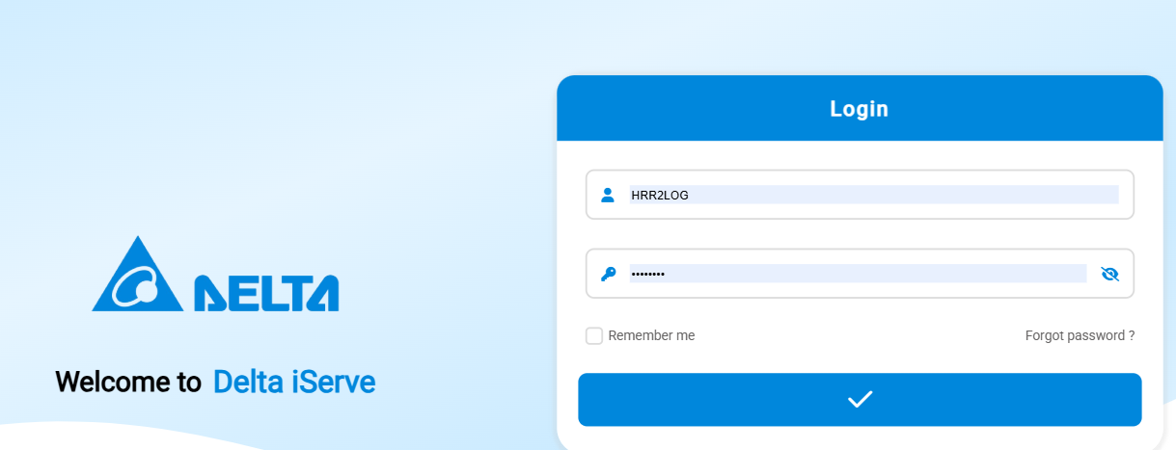

GO to the inventory receipt module and see the assigned receipt

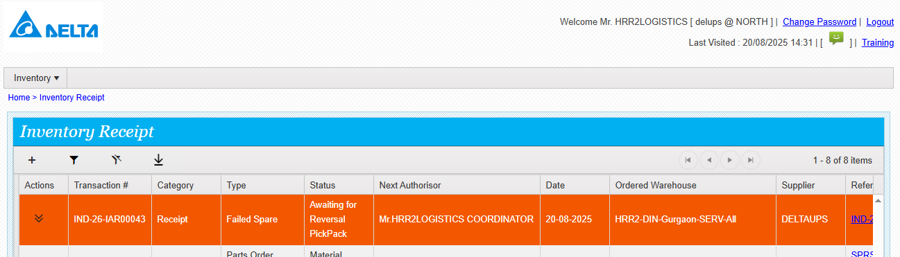

Click on action and see the actions available

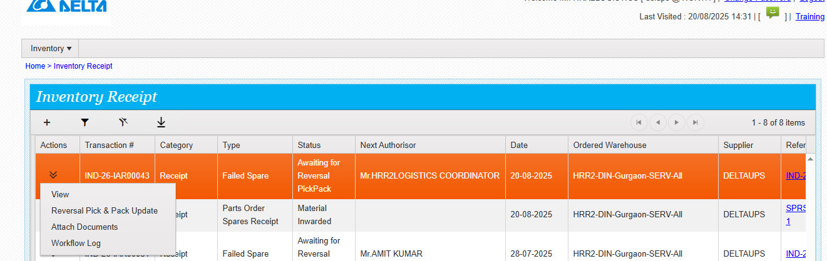

Click on reversal pick pack

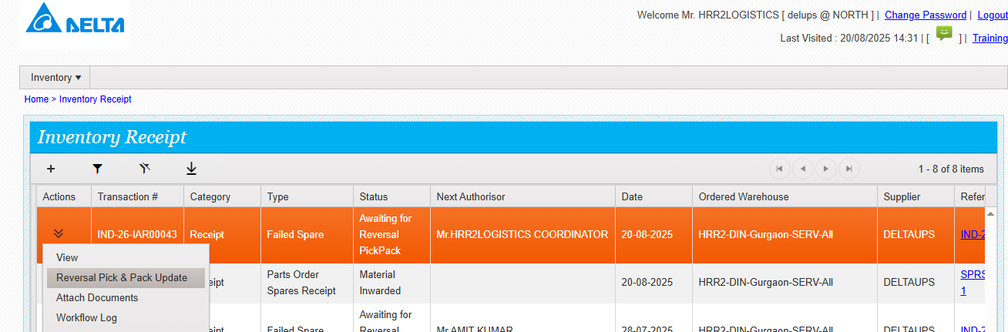

Enter the required details and submit

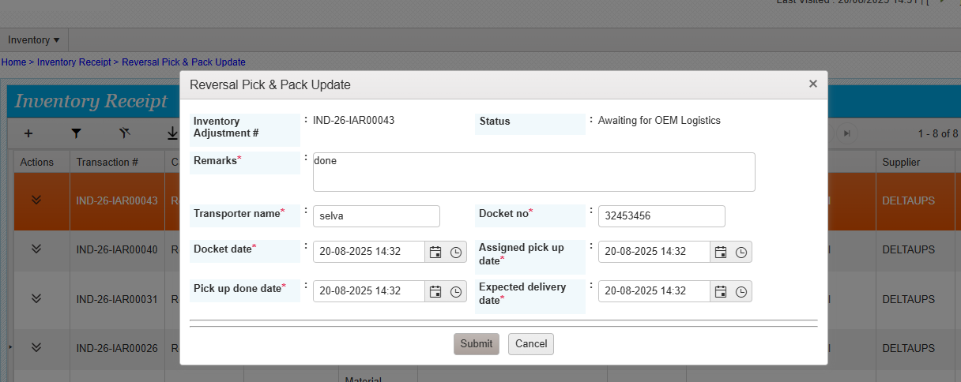

Reversal pick pack done successfully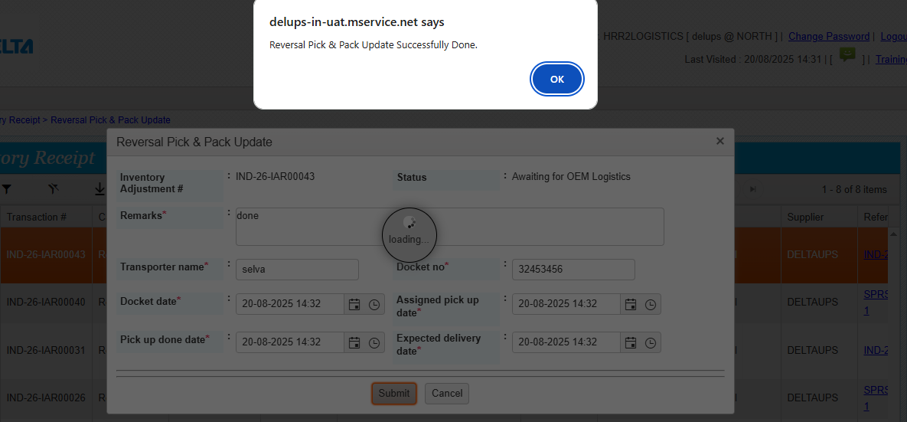

Now the status is awaiting for delivery update

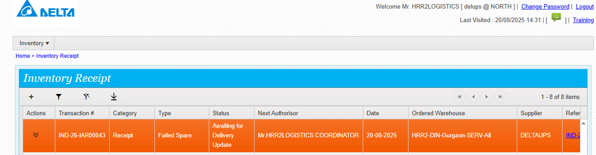

Click on delivery update and fill the required details

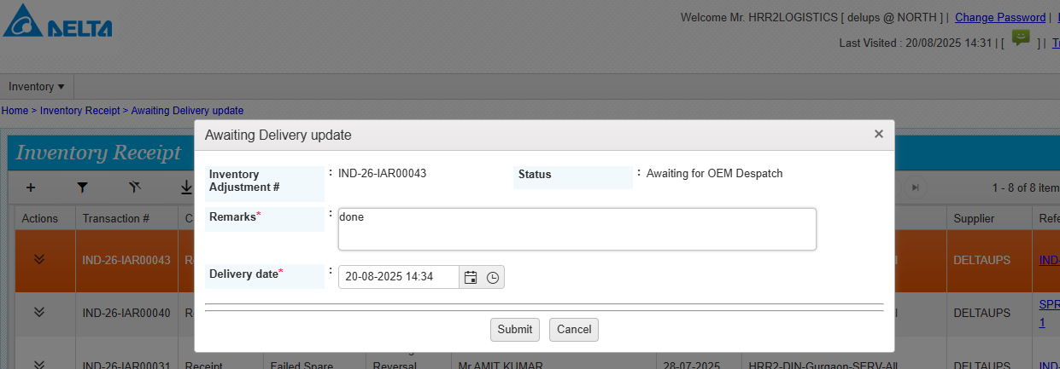

Delivery update done successfully

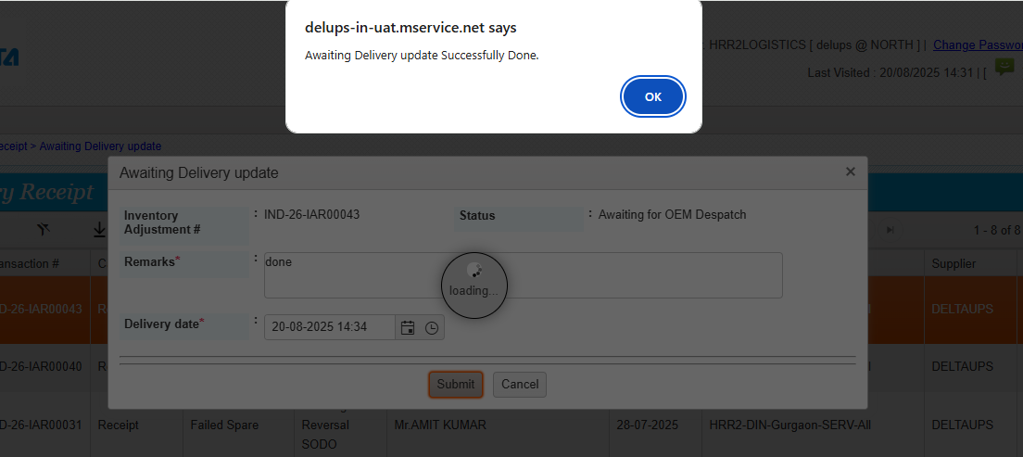

Now the status is awaiting for GRN

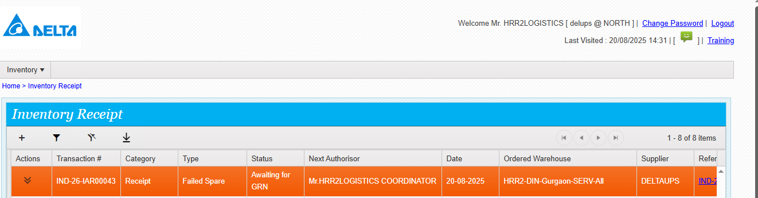

Click actions and see the actions available

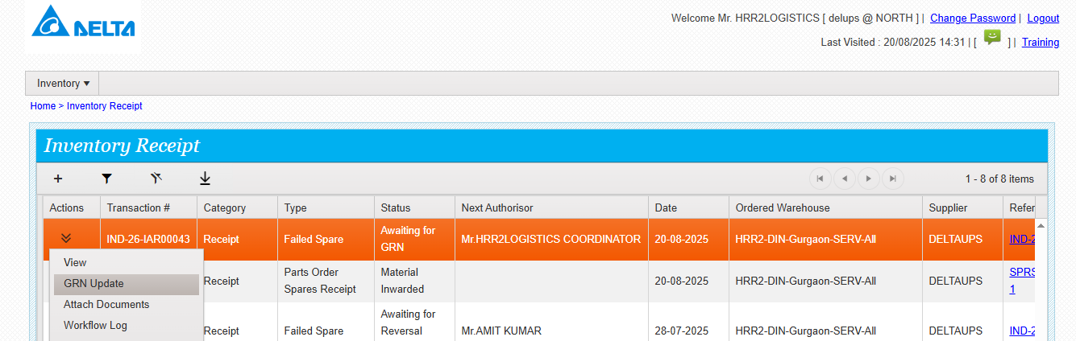

Click on GRN update and fill the details , input is possible

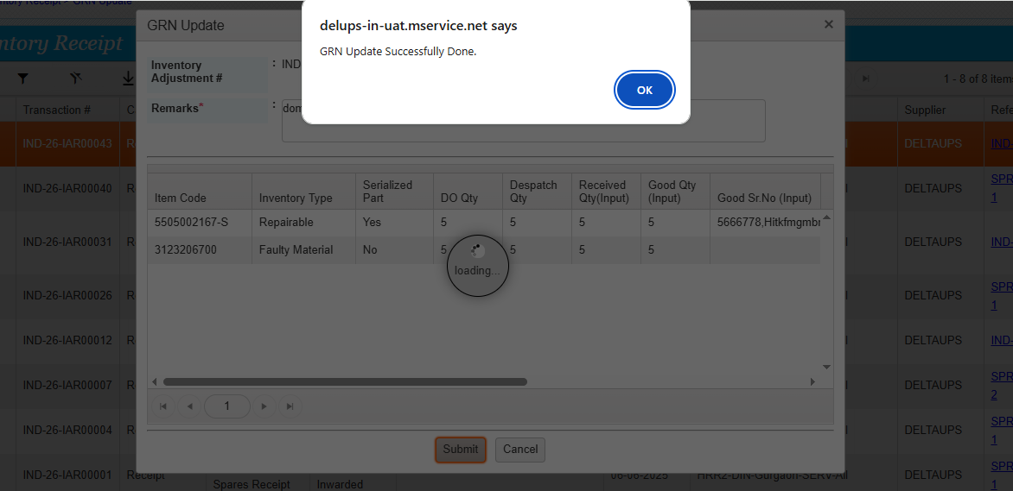

Failed part inward done successfully

